11.AIM:-To implement UML diagrams for Conference management system..

1.USE CASE:

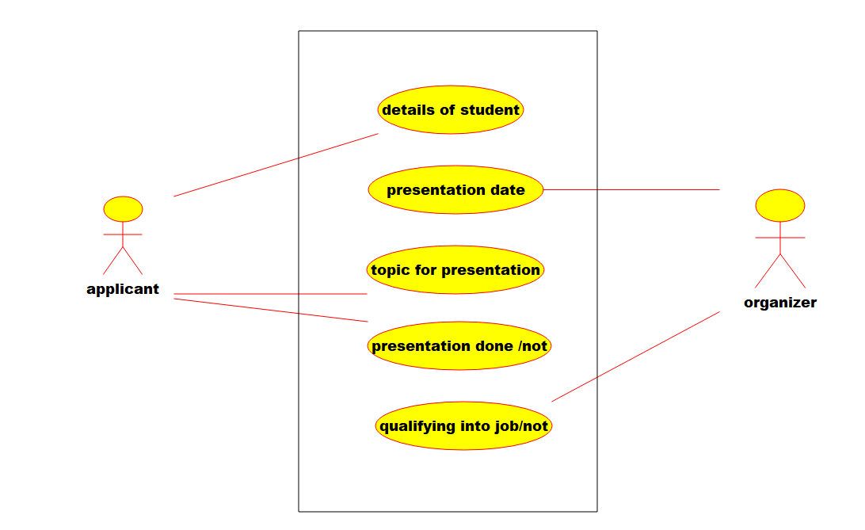

2.Deployment diagram:-

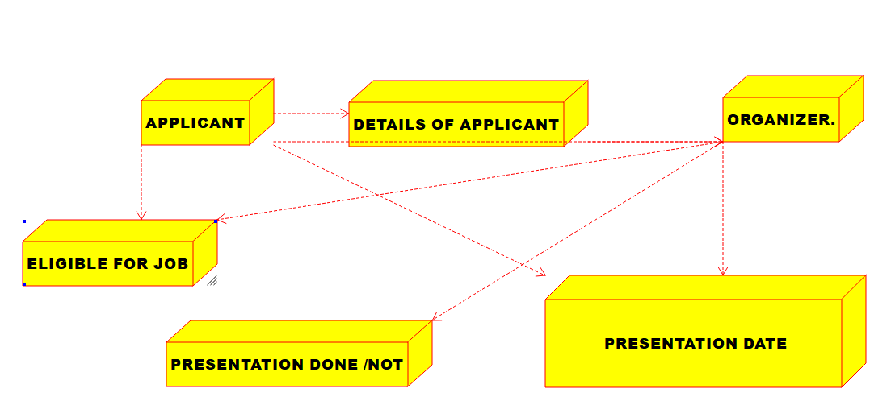

3.PACAKAGE DIAGRAM.:-

